DATABASE DESIGN
USERINFORM
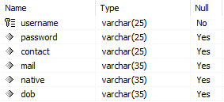

VERIFICATIONCODE
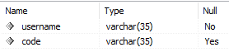

ER DIAGRAM

